Player Position Card – 4-4-2

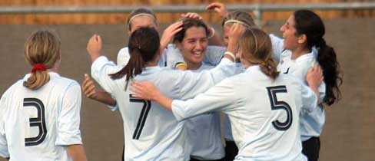
- 10

11 4 8 7

3 6 5 2

1

4-4-2

Roles & Responsibilities of Number 5 (Right-Sided Centre Half)

No. 5 – Centre Half

- High Pressure Upon Balls Into Strikers Feet (Not Beyond Start Of Centre Circle – In This Situation Drop And Protect Space Behind)

- Attack All Aerial Balls With Power, Purpose & Timing

- When No. 6 Attacks Or Pressures; Drop Deepest/Central To Provide Cover

- When No. 2 Shows Their Opponent Down The Line Move Deep And Central Into Six-Yard Box To Defend Cross

- Distribution

  - Play Long Angled Balls Behind Opposition When They Play High Pressure And/Or A Back Three
  - Play Sharp/Quick Passes To Full Backs & Centre Midfielders When Opposition Play Low Pressure

